
SOP Title: | eComm STOs Shipment Verification Process
Document Storage Location: | STACS/Management/SOPs – Logistics and Warehousing | Document #: | SEASOP421v100
SOP Originator: | Viraj Baraskar | Last Edited by: | Viraj Baraskar
Effective Date: | 10/31/2020 | Last Edited Date: | 11/12/2020
Other:

- Purpose
  - To establish a process flow for the verification of eCommerce(eComm) Stock Transfer Orders (STOs) arriving at the warehouse(WH) from locations outside the facility.
- Scope
  - Coppell – The process will occur when an eComm STO arrives from a location other than the WH facility.
- Responsibilities
  - SEA eComm team shall be responsible for providing all the necessary information to the 3PL eComm team when any STO is issued from a location outside the facility.
  - 3PL eComm team shall be responsible for tracking the STO in transit.
  - 3PL eComm team shall be responsible for picking it up from the dock when it arrives in the facility. Once delivered at the dock, the STO will need to be received as per the SLA for an Inbound STO.
- Instructions
  - The process begins when an STO is created for eComm which is scheduled to be delivered from a location other than the Coppell WH.
    - These STOs are shipped via delivery service companies.
  - The details of the STOs once a Delivery Order (DO) drops can be viewed in the load plan file generated daily.
  - Once the STO ships for Coppell WH, the tracking number(BOL) is updated in the load plan file as below
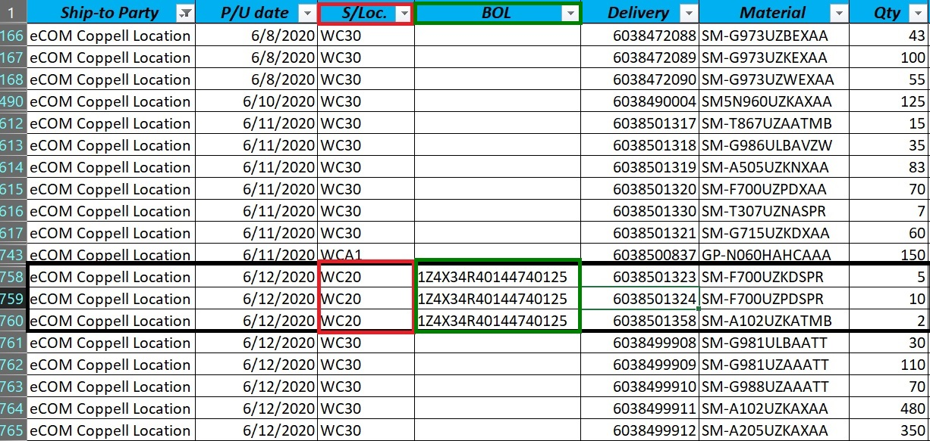
  - The tracking number(BOL) will be shared with the 3PL eComm team. Please send to the below email addresses.
    - Verline Morgan (Verline.MORGAN@geodis.com)
    - Craig Beasley <Craig.Beasley@geodis.com>;
    - Gary Turner <Gary.TURNER@geodis.com>;
    - Michael Beldowski <Michael.BELDOWSKI@geodis.com>
    - Eric Turner <eric.Turner@Geodis.com>;
    - Elba Sepeda <Elba.SEPEDA@geodis.com>;
    - Cierra Clemons <Cierra.CLEMONS@geodis.com>;
Please also copy:
- eComm Team(eCommTeam@sea.samsung.com)
  - The STO will be tracked twice a day by the 3PL eComm team and shall be called out in the Morning Report and EOD report sent everyday.
  - Once the delivery gets updated as “Delivered” in the delivery service company’s website, the 3PL eComm team shall be responsible for picking it up and moving it over to the eComm inbound area.
  - Upon arrival, the STO contents shall be validated immediately, both systemically as well as physically to verify that the contents and count match the packing slip attached with it.
  - If a discrepancy or visible damage is found, the SEA eComm team shall be informed immediately. The contents of the STO and the packing slip, along with the carton and /or master carton and/or pallet shall be carefully kept in the 3PL eComm team’s possession for claims purpose. Failure to do so will result in a claim filed against the 3PL.
  - If the contents and count are both validated and found to be accurate, the STO will need to be received as per the SLA.
    - The SLA to receive and put away the STO is within 24 hours upon arrival and it begins when the STO is delivered to the dock.

